` ``
PREP  - Amp heaters on (Heat indicator lit!)  - Map out plate layout  - Printout these 2 pages out separate  - Label Reaction Mix tubes  - 1.5mL EDLB tubes  - 4 rxn per RM tube  - 1 RM tubes per PGS batch (#68)  - Calc amount of CLAMP MM needed  - 55 µL x # batches = _________  - Use single source tube  - If larger run combine MM tubes  - Label strip8 tubes (or use plate)  - Make 1mL 1XISS (fill out on next pg) | 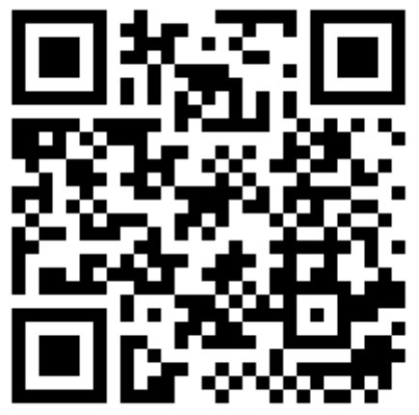 | Validation PGS  Form Link
 |  | Location: MBC
 | Name:
 | Date and Time:

RUN
- Get PCR cold block out 10min before - put plate or strip8 tubes in
- Get blue tube cold block out 10min before - keep all RM tubes in this
- Make Reaction Mixes for all tubes:
- Add 46 µL of each PGS to each RM tube (making sure to match lot#'s)
- Add 55 µL of CLAMP MM to each RM Tube
- Vortex for 10s and centrifuge/shake down
- Add 23µL of reaction mix to each of 4 wells {at bottom, no blowout, no tip touch}
- After adding RM to all reconfigure POS strips together and NEG strips together
- Add NEG control (1XISS) to those columns/tubes - cap
- Prep Pos Control: TPC100 - thaw 30s, add 20uL of Ultra Pure water (clean glove!)
- Add POS - TPC50 to each POS tube PGS Lot# Prefix ____

 | POS | NEG | POS | NEG | POS | NEG | POS | NEG | POS | NEG | POS | NEG
 | 1 | 2 | 3 | 4 | 5 | 6 | 7 | 8 | 9 | 10 | 11 | 12
A 1 | POS 0040 | NEG 0040
B 2 | POS 0040 | NEG 0040
C 3 | POS 0041 | NEG 0041
D 4 | POS 0041 | NEG 0041
E 5 | POS 0042 | NEG 0042
F 6 | POS 0042 | NEG 0042
G 7
H 8

PREP  - Heaters on (Heat indicator lit!)  - 1X Inactivation Saline Soln ready  - Reaction mix strip8/plates ready  - Safety Procedures:  - lab coat  - gloves  - face mask  - face shield or goggles  - Alcohol wipe sample tubes |  | Amp Run Sheet Short  Any System | version  1.3mod

AMPLIFICATION REACTION  - Thaw Reaction Mix (if frozen)  - Setup tips to align with reactions  - Add 2μL from each sample tube  (pipet up& down 5X, blowout in liquid, tip touch)  - Heat 65°C for 25 min, set timer  - Intake sample tubes in App  - Put sample tubes in fridge  - Remove Reactions and Let cool for 1 min before photo  - Take photo in lightbox | Amp Heater: |  | Strip8 Tubes or Plates
 | Reaction Mix: Fresh
 | CLAMP MM Lot and EXP:
 | Num Reactions (including controls):
Pos Ctrl ID: TPC50 from TPC_
Ultrapure Water ID:
 | Neg Ctrl ID (today's 1XISS):
 | Initial Inconclusives?:
- Crop photo and apply vivid filter  - Update results in App  - Log Run with Form link | Notes:

